A FREE GUIDE FROM
[PRACTICE NAME]
Better Sleep Without Pills
How your sleep position, pillow, and mattress affect your pain — and what to change tonight
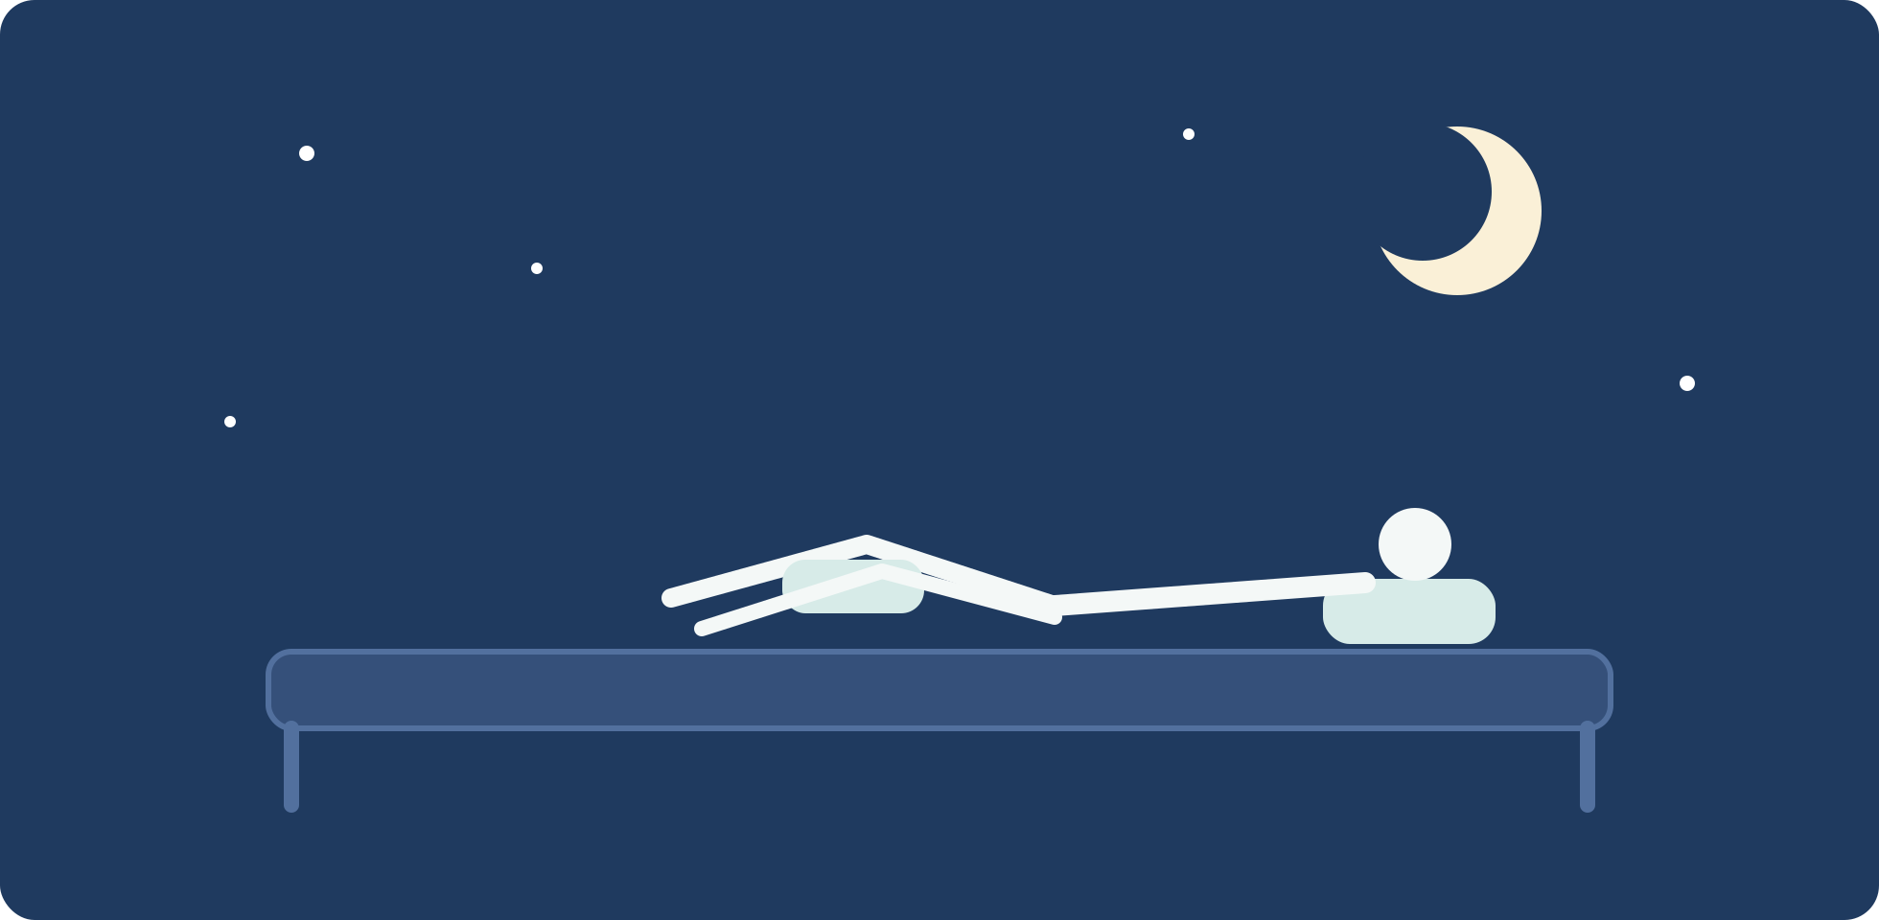
INSIDE THIS GUIDE
✓ The three sleep positions, ranked — and how to upgrade yours
✓ The 10-second pillow test most people fail
✓ How to tell if your mattress is helping or hurting
✓ The 90-minute wind-down that quiets both mind and muscles

THE PAIN–SLEEP CYCLE

Bad sleep makes pain worse. Pain makes sleep worse.
If you wake up stiffer than you went to bed, you're not imagining it. Sleep is when your body does its repair work — muscles relax, tissues recover, and your spinal discs rehydrate after a day of being compressed. Get too little sleep, or spend it in a position that loads your neck and back, and you shortchange that repair.
It runs both ways: research shows poor sleep lowers your pain threshold the next day, and nighttime pain fragments your sleep. That loop — hurt, sleep badly, hurt more — is one of the most common patterns we see. The good news is that it can be interrupted from the sleep side, tonight, without medication.
Three physical factors do most of the damage: your position, your pillow, and your mattress. Let's fix them in that order — cheapest first.

FACTOR 1 · FREE

Your sleep position, upgraded
You spend six to nine hours a night in this position — it is, by hours, the biggest posture of your life. Here's the ranking, and the one-pillow upgrade for each:
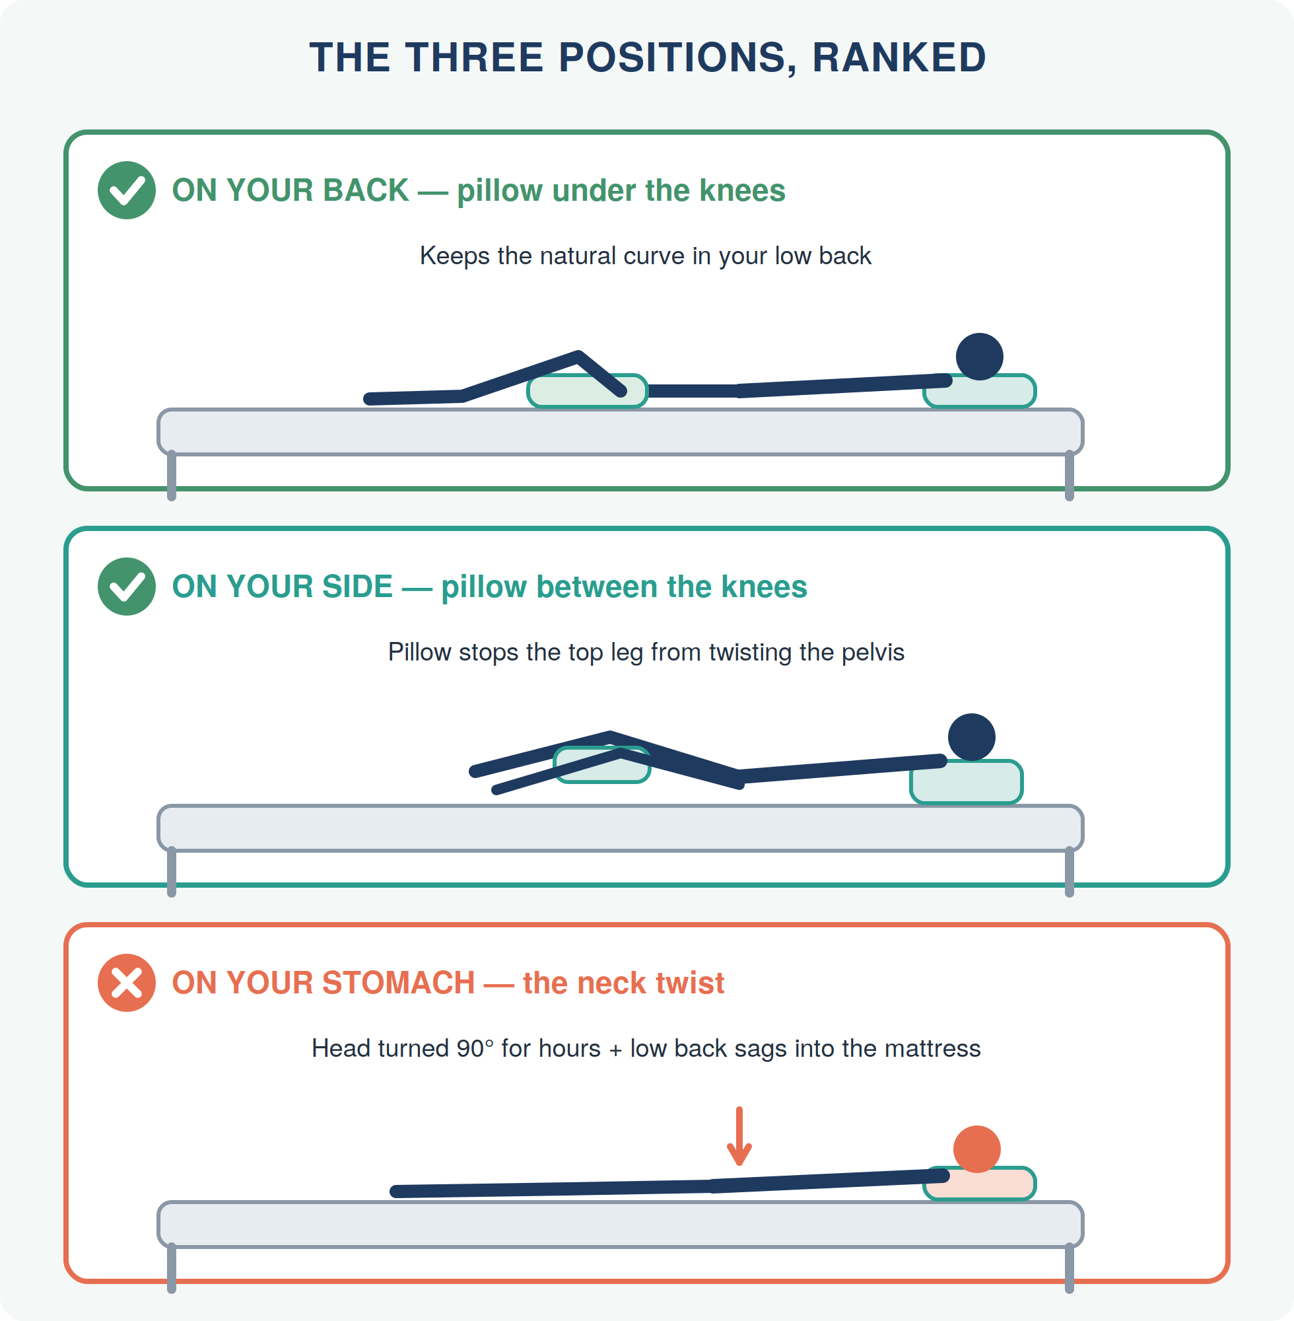
Stomach sleeper since childhood? Don't fight it cold turkey. Transition via the 'half-stomach' position: mostly on your side with a body pillow hugged in front and the top knee resting on it. You keep the pressure-on-the-front feeling without the 90° neck twist.

FACTOR 2 · THE 10-SECOND TEST

Your pillow has one job
A pillow isn't for your head — it's for your spine. Its only job is to fill the gap between your head and the mattress so your neck stays in a straight line with the rest of your back:
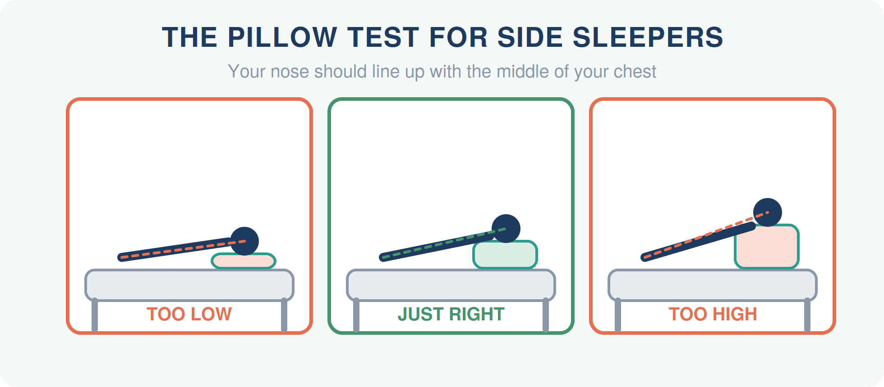
- Side sleepers need the thickest pillow — it must fill the full width of your shoulder. Test: lie down and have someone photograph you from behind; your nose should line up with your breastbone.
- Back sleepers need a medium-low pillow that supports the neck curve without pushing the head forward. If your chin points at your chest, it's too high.
- Replace it when it folds in half and stays there, or when you find yourself sliding a hand underneath — that's your body asking for the height it isn't getting.
FACTOR 3 · THE BIG ONE

The mattress check
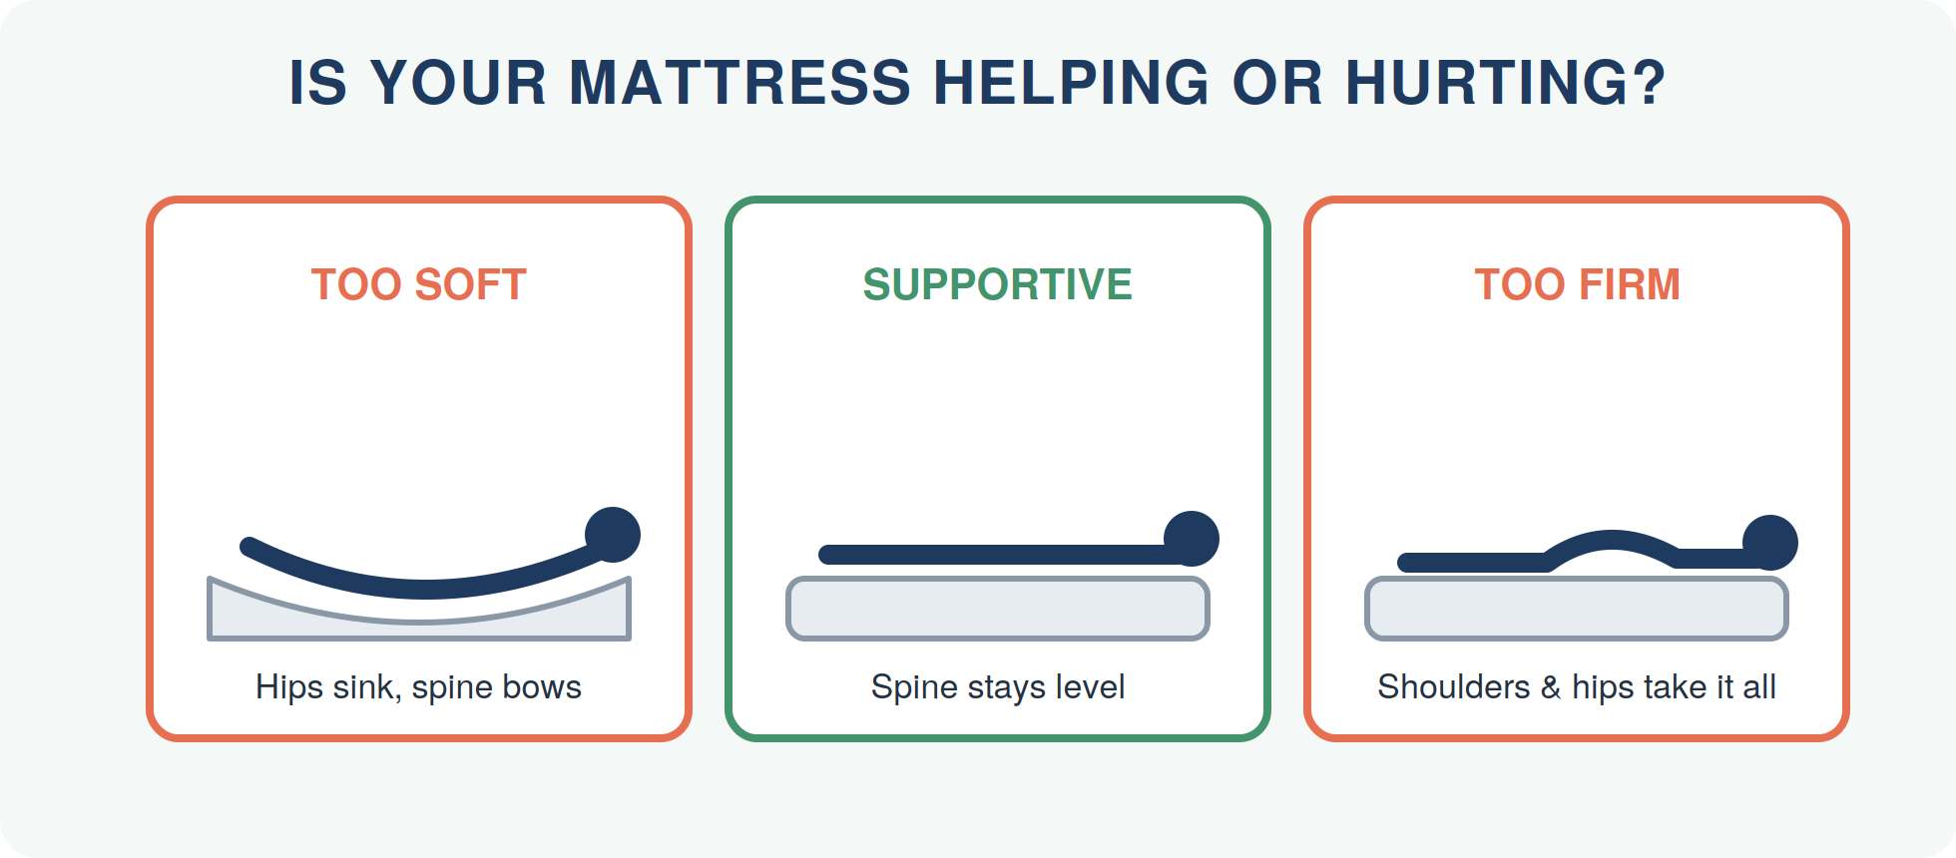
The morning clue: pain or stiffness that's worst when you wake and eases within 30–60 minutes of moving around points strongly at the bed (or the position you sleep in it). Pain that's the same all day usually has other causes.
- Age check: most mattresses support poorly after 7–10 years, even if they still 'look fine.'
- The hotel test: if you consistently sleep better away from home, your bed is a suspect.
- Medium-firm is the best-supported starting point in research on back pain — firm enough to keep hips level, soft enough to let shoulders sink slightly.
THE ROUTINE

The 90-minute wind-down
Position, pillow, and mattress fix the mechanics. This routine fixes the nervous system — because a body that goes to bed tense sleeps tense, and tense muscles amplify pain overnight:
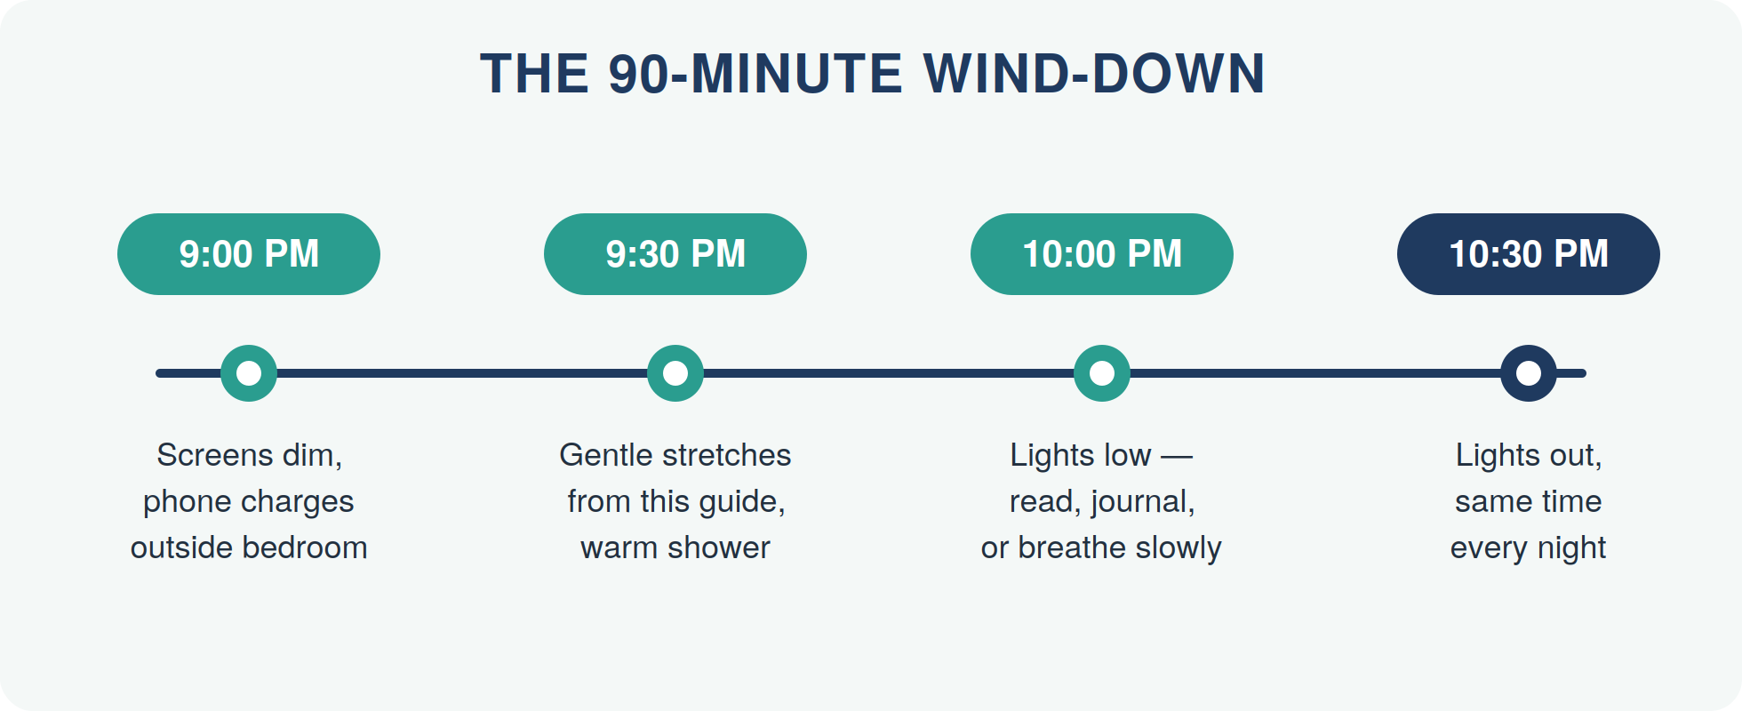

Ten quick wins for deeper sleep
- Same wake-up time every day — yes, weekends too; it anchors your body clock
- Bedroom cool (around 18 °C / 65 °F), dark, and quiet
- Caffeine ends at lunchtime — its half-life is 5–6 hours
- Alcohol may start sleep faster, but it fragments the second half of the night
- Finish intense exercise 2–3 hours before bed; gentle stretching is fine anytime
- Big meals 3 hours out; a light snack is fine
- Phone charges outside the bedroom (an old-school alarm clock costs very little)
- If you can't sleep after ~20 minutes, get up and read something dull in dim light
- Warm shower or bath 1–2 hours before bed — the cool-down afterwards is a natural sleep signal
- Write tomorrow's to-do list before you lie down, so your brain can put it down

AN HONEST NOTE

When sleep isn't the whole story
If you've upgraded your position, passed the pillow test, ruled out the mattress, and kept the wind-down for two weeks — and your nights still involve pain — the problem usually isn't your sleep setup. It's what your spine is carrying into bed each night.
- Pain that reliably wakes you at the same depth of night
- Numbness or tingling in your arms or hands while sleeping
- Needing to sleep in a recliner or 'nest' of pillows to cope
- Morning headaches that fade by mid-morning
- Stiffness every single morning for more than 30 minutes
These patterns respond poorly to sleep hygiene alone because the driver is mechanical — restricted joints, irritated nerves, muscle guarding. That's assessable and, in most cases, very treatable.

YOUR NEXT STEP
Give your body a night off from pain.
If pain is still setting your sleep schedule after two weeks of these changes, let's find out what's really driving it. A thorough assessment — spine, posture, movement — tells you exactly what your nights are up against.
READER OFFER
[Special Offer — e.g., a complimentary posture & spine check for new patients who mention this guide]
Mention this guide when you book.

[PRACTICE NAME]
📞 [Phone Number]
🌐 [Website / Online Booking Link]
📍 [Street Address, City]
🕐 [Opening Hours]

Medical disclaimer
This guide ("Better Sleep Without Pills") is provided for general educational purposes only and is not a substitute for professional diagnosis, advice, or treatment. Always consult a qualified healthcare provider about your individual situation before starting new exercises or self-care routines. If you experience severe pain, numbness, weakness, or any of the red-flag symptoms described in this guide, seek professional care promptly. © [Year] [Practice Name]. You are welcome to share this guide in its complete, unmodified form.

